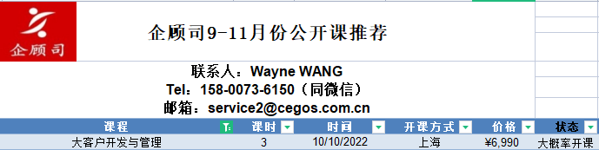
大客户开发与管理
Developing and Managing Key Accounts
课程意义：
大客户作为企业生存与发展的重要资源，成为了企业间竞争的主战场。因此，哪些是我们的准大客户？如何建立与准大客户之间的合作？如何保有我们的大客户？
本课程将围绕这三个问题，引导参加者系统地关注大客户的问题，从而帮助他们在竞争的市场中赢得更多的大客户。
参加对象：
* 负责开发和维护重要客户的销售人员、客户经理
* 跟踪管理那些负责重要客户的销售人员的销售经理
内容大纲：
1. 对大客户的认知和定位
* 了解您的大客户、市场、市场细分
* 面对大客户时销售队伍的任务
* 大客户与一般客户的区别
* 大客户销售组织和资源分析
2. 大客户的战略管理
* 大客户的战略分析
* 大客户需求的分析
* 大客户决策小组成员的定位分析
* 如何有效地掌握大客户的重要信息
* 如何制定针对大客户的行动计划
* 如何定制大客户的销售方案
3. 对大客户进行分析
* 了解企业、产品及环境、市场的SWOT分析
* 理解本公司产品及服务的价值和附加值
* 客户对销售人员的期望是什么
* 明确大客户的采购流程及战略作用
* 测试：销售风格和采购风格分析
* 强化顾问式销售技巧—销售六步法
* 强化针对大客户的战略提问技能
* FAB及Q-FAB-Q表达技巧
* 处理大客户常见的异议和疑虑
4. 针对大客户的销售谈判及顾问式销售法
* 创造你的产品、服务及解决方案的差异性，有效地吸引大客户的采购关注、认可、行动
* 对大客户的销售谈判实力进行分析
* 销售谈判的五个黄金原则，抗压和避开陷阱
* 了解大客户的需求动机及潜在个性化需求，进行个性化定位分析，找出大客户的量体裁衣式的整体销售方案
* 大客户销售的实例分析
Program Outline：
1. Recognition and positioning of the key accounts
* Understanding your market, segmentation and key accounts
* Tasks of sales team while facing key accounts
* Differences between key accounts and general customers
* Analyzing sales organization and resource of the key accounts
2. Strategic management of the key accounts
* Strategic analysis of the key accounts
* Key accounts demand analysis
* Positioning analysis to DMU of key accounts
* Collecting important information effectively
* Setting up your relevant and proper action plan
* Setting your tailor-made sales proposal
3. How to analyze the key accounts
* Understanding the SWOT analysis of client’s culture, situation, product and market
* What’s your product’s value and added value
* Client’s expectation to the sales people
* Identifying the purchasing procedure and strategic function of the client
* Selling and purchasing style analysis
* Reinforcing the consultative selling skills – 6 steps
* Key accounts strategic questioning
* Using FAB and Q-FAB-Q presentation skill
* How to handle clients’ objections and misunderstanding
4. Sales negotiation and consultative sales style while facing key accounts
* Differentiating your solutions to gain awareness, acceptance and consideration
* Negotiation power analysis
* Five golden principles of the sales negotiation
* Understanding clients’ needs and analyzing personalized needs
* Practical case analysis

